**Blenheim Grange Maintenance Plan**

**Background**

In 2016, Carbrooke Parish Council accepted ownership of the Open Spaces at Blenheim Grange on behalf of the community. The Parish Council is responsible for the maintenance of the Open Spaces, together with the play area on Lancaster Avenue and the Community Cabin on Washington Drive. The Parish Council maintains the war memorials near Norwich Road, three noticeboards (two at Blenheim Grange and one at Knights Park) and the litter and dog bins situated around the Blenheim Grange estate. The Council also maintains the two bus shelters on Norwich Road opposite Washington Drive.

Since assuming ownership of the land at Blenheim Grange in 2016, the Parish Council has completed the following:-

* Installed a new play area on Lancaster Avenue. The purchase of the equipment was entirely grant funded.

* Laid down a new path next to the play area, together with a new grassed area.

* Installed two 5 a side football goals near the play area.

* Installed new metal fencing at the front of the estate to the left and right of the War Memorials on Washington Drive.

* Installed new drop-down locks on the path between Washington Drive and Norwich Road to control access.

* Funded tree surveys and carried out all works recommended in the surveys, as well as felling trees/branches in accordance with guidance from the Council’s contractor. Where it can, the Council has planted trees to replace those that have been felled.

* Installed new dog and litter bins.

* Cut back and cleared areas of Open Space around the estate.

* Installed two bus shelters on Norwich Road opposite Washington Drive.

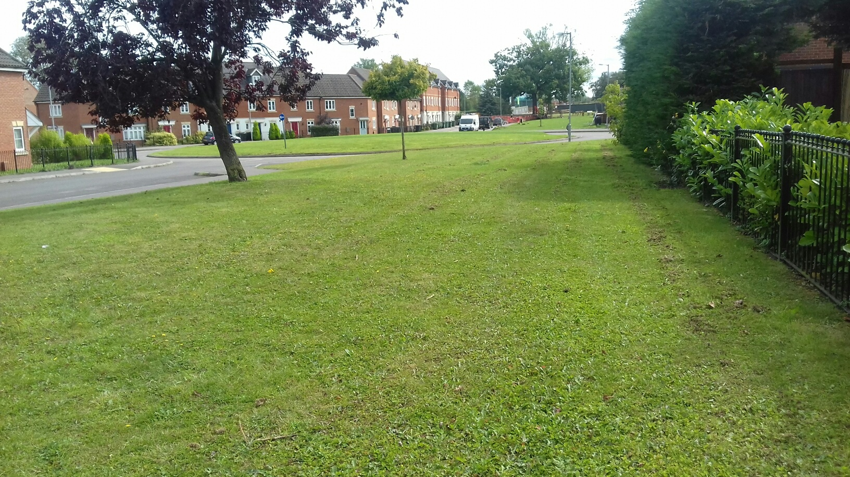

**Finance**

In March 2016, a Commuted Sum of £241,013.80 was transferred to the Parish Council for the maintenance of the Open Spaces at Blenheim Grange. After expenditure on the above items, the sum of £197,826.19 was invested in three separate accounts, as follows:-

Unity Trust Bank £85,000

Scottish Widows Bank £85,000

Lloyds Bank £27,826.19*

The Commuted Sum can only be used for the maintenance of Blenheim Grange and for no other purpose. In view of the current low interest rates, the rate of return on this money is minimal. The Parish Council has therefore had to use part of its Precept to cover its current costs in respect of the maintenance of the Open Spaces at Blenheim Grange in addition to the Commuted Sum. The Precept is the local tax levied by Breckland Council as part of the Council Tax bill. It is the main source of the Parish Council’s income.

* The balances of the above accounts have since changed as funds are spent, although a small amount of interest has been received on the Scottish Widows and Unity Trust accounts.

**Aims and Objectives**

The aim of the Management Plan is to set out the Parish Council’s key priorities and objectives for the management and maintenance of Blenheim Grange. The Parish Council wishes to ensure that the land and assets it holds on behalf of the parish are administered efficiently, in the best interests of parishioners and in a manner that represents the best value to the community.

The Management Plan does not relate to Carbrooke as a whole. It has been specifically drawn up to help the Council plan and promote its vision for Blenheim Grange in the short to medium term. A Management Plan for the remainder of the parish was completed in January 2020 and is available on the Parish Council’s website.

The Management Plan will be regularly reviewed in the light of new housing developments at Blenheim Grange and in accordance with the Council’s aims and objectives, which are based on the needs and requirements of residents.

**It is hoped that the Plan will help local residents to have a better understanding of what the Parish Council does and that it will encourage them to come forward with their own ideas for improvements at Blenheim Grange.**

**Annual Maintenance Costs**

The current maintenance costs in respect of Blenheim Grange are available on the Council’s Budget document. A copy of this is on the Parish Council’s website (carbrookepc.info) or from the parish clerk ([carbrookeparishclerk@gmail.com](mailto:carbrookeparishclerk@gmail.com)).

**Current Aims and Objectives**

The Parish Council is currently pursuing the following aims and maintaining the following facilities.

**Adoption of the Roads**

The Parish Council is in consultation with the Taylor Wimpey housing consortium regarding the completion of the roads at Blenheim Grange and the adoption of the roads by Norfolk County Council.

**Anti Social Behaviour**

Anti social behaviour affecting people’s enjoyment and use of the Open Space land takes many forms. Examples include littering, dog owners not clearing up their dog foul, speeding, riding motorbikes on the pavement or open spaces, drinking in public places and fly-tipping.

In response, the Parish Council has installed litter bins on the estate. Councillors, some members of the public and members of Blenheim Grange Residents Association carry out regular litter picks.

The Parish Council has installed dog bins and is seeking to install No Dog Fouling signs around the estate with the support of Breckland Council.

Speeding. The adoption of the roads will allow the Police to enforce speeding and parking violations.

Drinking. A file of evidence of anti social drinking is to be presented to Breckland Council with the aim of creating No Drinking zones where necessary.

Fly-tipping. As the Parish Council owns the Open Space land, it cannot request the removal of fly-tipped items by Breckland Council. Some items have been removed by Orbit Housing Association as part of a clear up in 2017. The Parish Council has paid its contractor to remove some items.

**Bus Shelters**

The Parish Council has installed a bus shelter on each side of Norwich Road opposite Washington Drive.

**Community Cabin**

As part of the land transfer in 2016, the Parish Council assumed ownership of the Community Cabin on Washington Drive. The Cabin is insured by the Parish Council, but usage has been stopped under the current Covid restrictions.

**Community Centre**

As part of the Westmere Homes development, the Parish Council will accept ownership of a new Community Centre to be built off Lancaster Avenue. It is anticipated that this will take place toward the end of 2021.

The Parish Council has set aside funds in its reserves and will need to fit out the building and purchase all necessary equipment.

The Community Centre will be open for hire for community events, individual users, parties and so on.

The Parish Council will prepare a full plan Business Plan for the maintenance and running of the Community Centre.

A Management Committee will be established.

**Noticeboards**

The Parish Council maintains two noticeboards at Blenheim Grange and one at Knights Park. The Blenheim Grange noticeboards were re-stained in 2020.

**Open Spaces**

The Parish Council precepts towards the cost of the grass cutting, strimming and weed killing. The contract is put out to tender each year.

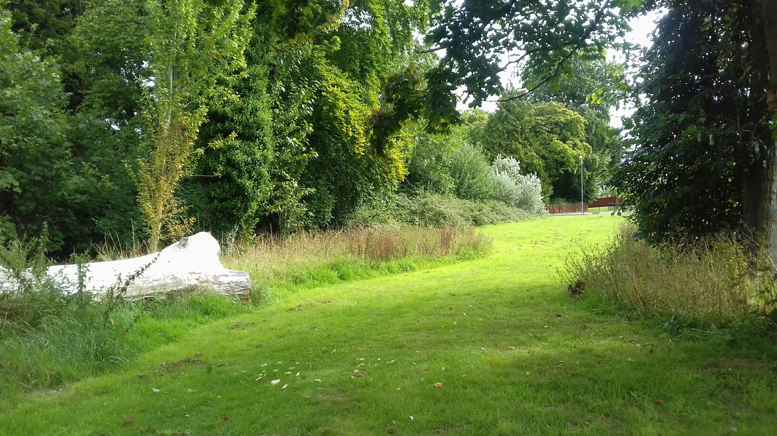

The Council is also responsible for the trees on the Open Space land. A number of the trees on the estate have Tree Preservation Orders on them. The Council works in conjunction with the Tree Officer at Breckland Council. Trees are felled/trimmed as necessary in accordance with expert advice. A tree survey was carried out in 2016. A second survey was carried out in 2019. In consequence, a number of trees were felled. Another tree survey will be carried out.

**Play Area**

The play area is regularly monitored on behalf of the Parish Council. The parish clerk makes periodic inspections. The warranty on the equipment has expired. The Council has therefore budgeted for any small repairs to the equipment and may use its insurance policy regarding larger items of repair.

The area suffers from an excess of litter and the Council is doing what it can to effect a solution.

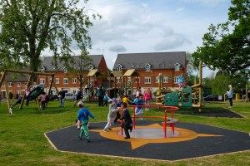

**War Memorials**

There are two War Memorials, one on either side of Washington Drive at its junction with Norwich Road. The Parish Council maintains these, together with the benches alongside them. The benches were stained and re-painted in 2020.

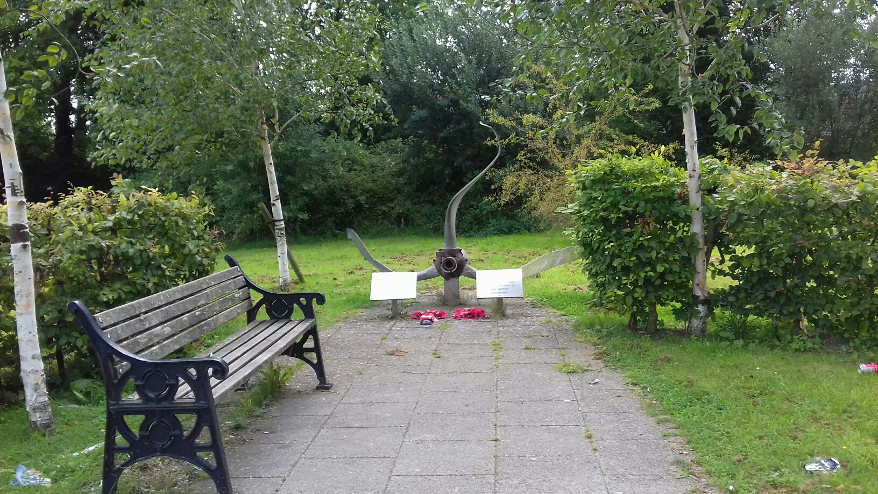

**Wooded Area off Anson Way**

The Parish Council has taken action regarding the trees in this area and has felled a number of trees in accordance with guidance.

**Future Aims and Objectives**

The increased population at Blenheim Grange as a result of the Knights Park and Westmere Homes developments will place a further level of responsibility on the Parish Council. The Parish Council will adapt its plans accordingly and its Management Plan will be a ‘living’ document which will be changed/amended as it progresses to meet current needs.

**Key Priorities**

The Parish Council has identified the following key priorities:-

* To complete the adoption of the roads.
* To reduce/eradicate anti social behaviour.
* To fit out and occupy the new Community Centre.
* To purchase new Outdoor Fitness equipment.
* To weed and keep tidy the flower beds on the estate.
* To maintain the wooded area off Anson Way.
* To maintain the trees on the estate.
* To revitalise the wildflower meadow at the front of the estate.
* To produce Information Boards and/or road maps of the estate.
* To put flower beds on the roundabout at Lancaster Avenue/Washington Drive and other locations.

**Feedback**

The Parish Council listens to and represents local people’s views. We welcome your comments on ways to improve Blenheim Grange. Please submit your ideas/proposals to the Parish Clerk at [carbrookeparishclerk@gmail.com](mailto:carbrookeparishclerk@gmail.com), or write to Oakleigh House, Shipdham Lane, Scarning, NR19 2LB.

**Monitoring the Plan**

The Parish Council will evaluate its progress against its activities. The Management Plan will be reviewed and updated at regular intervals.

This Management Plan was approved February 2021.